30-Minute Student Task

Build Your Own Rule-Based Python Chatbot

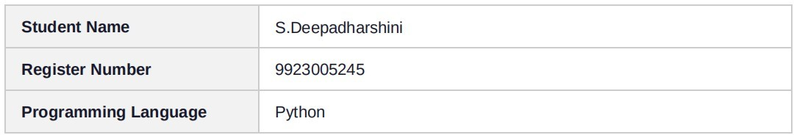

Assessment :
Build a simple rule-based Library Assistant chatbot in Python.
The chatbot should interact continuously with the user, recognize greetings and different library-related questions, provide suitable responses, and allow the user to exit the conversation.

Demonstration Evidence
The following pages contain screenshots of the Python implementation and the terminal execution:

Python Chatbot Implementation
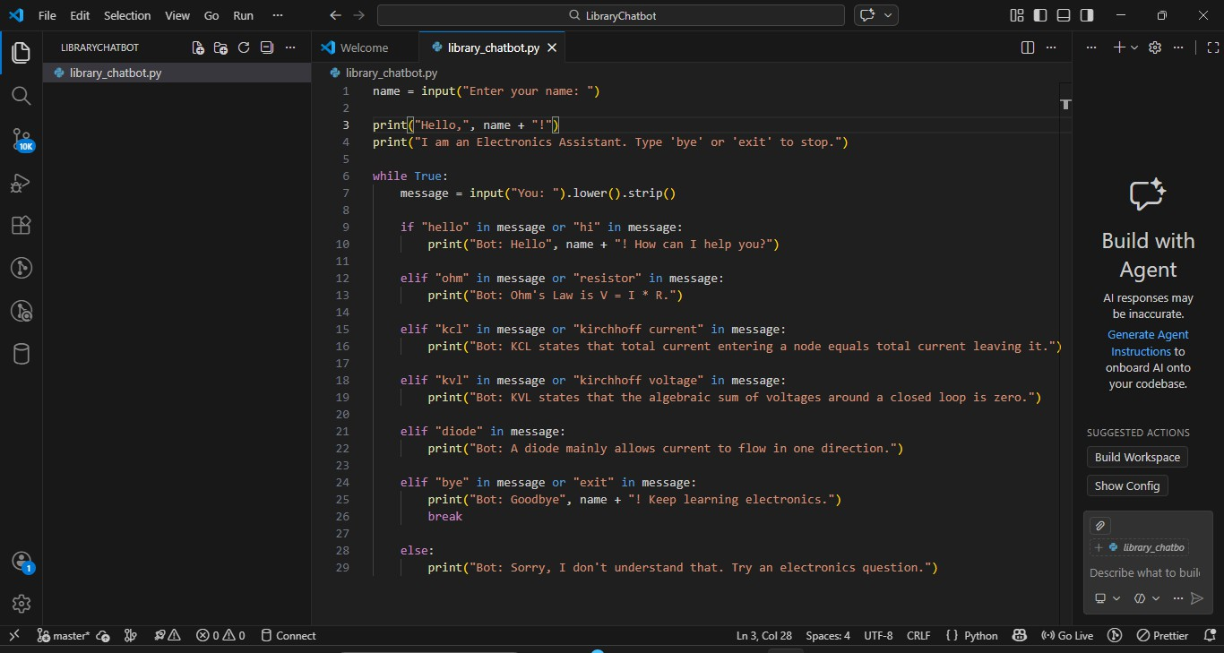
Screenshot of the Python program implementation

Chatbot Execution and Test Output
Terminal output showing greeting, question handling, an unknown message, and the exit command.
